SMART HOME

(Automatic light)

Submitted by:

Naveen.m.s

961819106038

INTRODUCTION

This is a n Ardino based system automated light system . This project idea based on an

Ardunio controller and whole project will give very good understanding how the system work .The step by step method is explained so that you can make this system .

The hardware connection,pin information and ardunio program is explained clearly

CODE:

float x,y,z,temp;

void setup()

{

pinMode(8, INPUT);

pinMode(5, OUTPUT);

pinMode(6, OUTPUT);

pinMode(A5, INPUT);

pinMode(A4, INPUT);

Serial.begin(9600);

}

void loop()

{

x= digitalRead(8);

y= analogRead(A5);

z= analogRead(A4);

Serial.println(x);

Serial.println(y);

Serial.println(z);

temp = (double)z / 1024;

temp = temp \* 5;

temp = temp - 0.5;

temp = temp \* 100;

if ( (x>0) )

{

if ((y<550)&&(temp>30))

{

digitalWrite(5, HIGH);

digitalWrite(6, HIGH);

}

else if((y<550)&&(temp<30))

{

digitalWrite(5, HIGH);

digitalWrite(6, LOW);

}

else if((y>550)&&(temp>30))

{

digitalWrite(5, LOW);

digitalWrite(6, HIGH);

}

else if((y>550)&&(temp<30))

{

digitalWrite(5, LOW);

digitalWrite(6, LOW);

}

}

else

{

digitalWrite(5, LOW);

digitalWrite(6, LOW);

}

}

FIGURE:

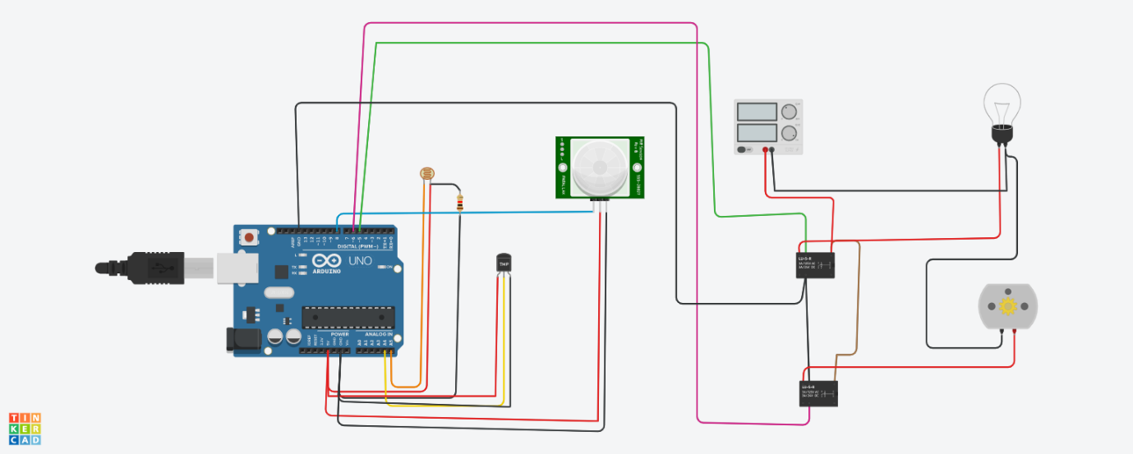

TINKERCAD LINK:

https://www.tinkercad.com/things/2TwdlBgxUTP-swanky-inari-albar